CURRICULUM VITAE
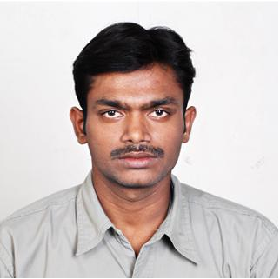
P. RAMI REDDY
C/o. Vinaya Vihara Hostal,
Room No: 72,
Andhra University,
Visakhapatnam.

Email: ramu.p85@gmail.com
Mobile: 98666 52830

OBJECTIVE:

To work with a committed team in order to enhance my technical, personal and organizational efficiencies, where I can contribute my skill set and be a part in the growth of the organization.

EDUCATION PROFILE:

- M.Sc Instrumentation (2006-08) from the Department of University Science Instrumentation Center (USIC), Andhra University, Visakhapatnam with 81%.

- B. Sc Electronics (MPE) (2001-04) from S.S& N College, Narasaraopet, Guntur, affiliated to Acharya Nagarjuna University with 73%.

- Board of Intermediate Education (Vocational CSE) (1999-2001) from S.S & N College, Narasaraopet, Guntur with 79.5%.

- Board of Secondary Education (1998-99) from Jayanthi Gurukul High School, Gurazala, Guntur with 76%.

TECHNICAL SKILLS:

- Computer Hardware Engineering.

- Advanced Desk Top Publishing (ADTP) from the institute New Softech Computer Education Center in Guntur.

- Typing Speed: 40-45 wpm

SOFTWARE SKILLS:

OPERATING SYSTEMS : MS DOS; Win9X/2000/Xp Professional
PACKAGES KNOWN : MS Office, DTP
LANGUAGES KNOWN : C;

EXPERIENCE:

- Computer Hardware Engineering with one year experience in Thribowan Technologies, Guntur.

- Computer Operator and Hospitalization Cashless Health Insurance Service with one year experience in BBR Multi Specialty Hospital, Balanagar, Hyderabad.

PERSONAL PROFILE:

NAME : PUTLURU RAMI REDDY

FATHER NAME : VENKATA REDDY

DATE OF BIRTH : 05-04-1984

NATIONALITY : INDIAN

LANGUAGES KNOWN : TELUGU, ENGLISH

MARITAL STATUS : SINGLE

PERMANENT ADDRESS : P. RAMI REDDY
C/O. P. LATCHI REDDY
DHARMAVARAM (P.O),
DURGI (M.D),
GUNTUR (D.T)-522612.

DECLARATION

I here by declare that the information furnished above is true to the best of my knowledge.

Date:

Place:
(P. RAMI REDDY)

