Newly Introducing with High Technology Combo Therapy

E-Therasonic – Estim + Combo
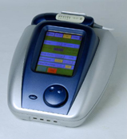

Hi Tech & Import Substitute
Ultimate Therapy with Ultrasound, IFT, High Volt, Premod, Russian, EMS, TENS and ultrasound + Estim combo. Battery / Mains operated. 2 / 4 Channel, Color touch screen LCD user friendly interface with preset programs, unique intensity controller in ultrasound applicator.

Higher end ULTRA SOUND (JUS-2)

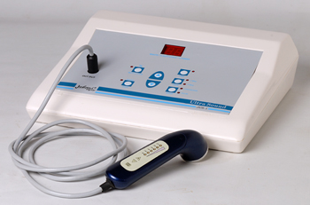

Features:-

- 1 Channel
- 1 & 3.3 MHz Pulsed and Continuous Freq.
- Intensity : 3.0 W/Cm²
- Digital Display : Duty Cycle, Power, Timer
- Digital Applicator with Intensity Control in built.

Muscle Stimulator

Micro Stim 1304 D
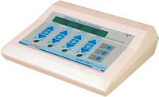

Features:-
Different Treatment simultaneously
Selectable 4 frequency, treatment time and contraction time.
Trapezium Wave for smooth simulation.

CPM – Continuous Passive Motion

- CPM Deluxe with EMS and IFT

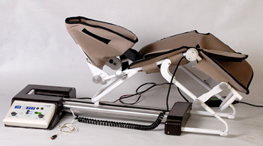

Features :-
- Digital Display & Controls
- Operation Mode : CPM/ IFT and EMS
- Emergency Stop Patient Switch
- Selectable :
  - Extension / Flexion Angel (10˚ - 120˚)
  - Treatment Time : 1-60 min
  - Speed : 30˚ / min - 150˚ / min

Auto Traction

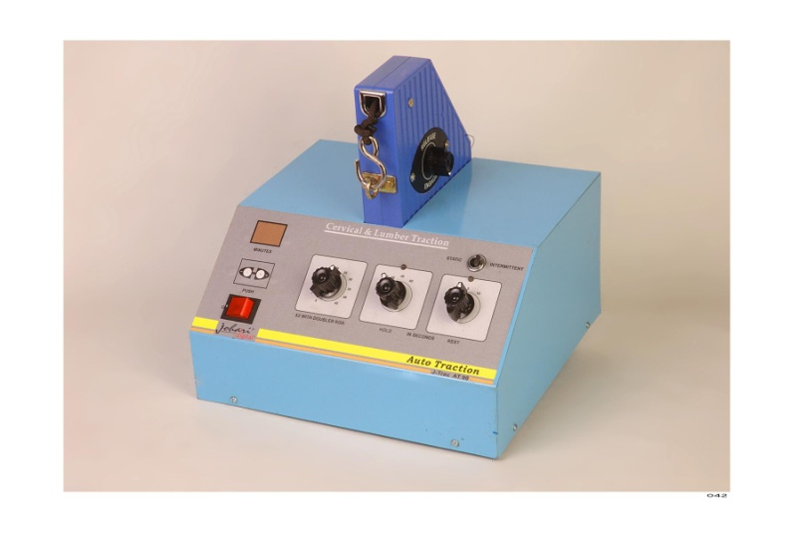

Features:-
Digital Auto Traction
Modes: Static / Intermittent
Weight Adjustment From 5-90 Kg
Treatment timer, Hold / Rest time.

Traction Bed

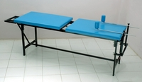

Size : 7.5 ft x 2 ft x 2.5 ft

Portables (For Off sight treatment)

STIM 3 : TENS , EMS & IFT

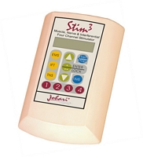

Features:-
Four channels to treat four body area.
Large LCD Offers easy menu selection.
IFT – 5000Hz with 3 Sweep (1-250Hz)
EMS: Russian 2500Hz, Convl.
TENS : Burst, Modulation, Normal
Treatment Time : 1-60 min
2 Hours on Rechargeable Battery and A/c mains

PORTABLE KIT (TENS, EMS & IFT)

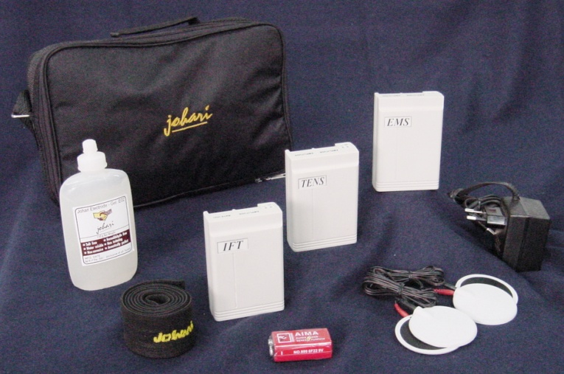

Features: -
Easy to carry any where
Profitable at off sight treatment
Works on Battery and AC mains

Clinical TENS

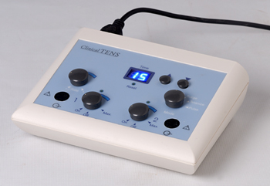

Features:-
Two Channels
Digital Timer
Patient Switch: Intensity Control.
Selectable Modes
Pulse
Surge
Tetanize
Reciprocation

Nerve & Muscle Stimulator

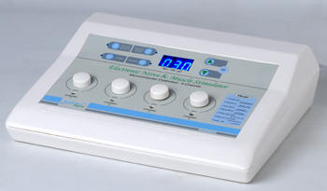

Features:-
Microcomputer Controlled digital unit.
Four Body areas treatment simultaneously
Seven Preset programs for easy selection.
Digital Display of Count Down time.
Treatment time : 1-60 min

TR-841 Torc Plus

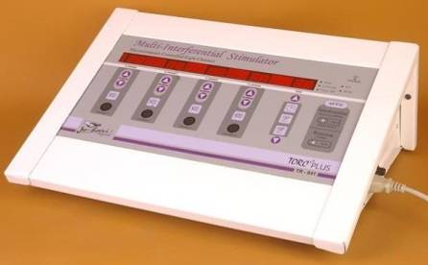

Effects :The units uses Interferential frequency of 4000 Hz which penetrates deeply into tough body tissues & activates lipolysis and stimulates the tough muscle fibers.

Benefits
Immediate Inch loss
Selective firming action of very specific and most difficult body portion i.e. Buttocks, Abdomen, Thighs.
Strengthening of Muscles – Russian Stimulation
Spot & Volume reduction
Four body area treatment simultaneously
Pain Releif
Large are coverage for treatment

ULRTA TORC
ULTRA TORC – A New Concept towards Medical Spa
 | Ultra Torc - A new therapeutic concept of medical spa  Ultra Torc is a sleek trolley based multi-funtional device that generates unique electrotherapy waveforms, ultrasound and sub-dermal therapy - a proven concept, in muscle stimulation, cellulite management & skin rejuvenation. The electrical stimulation outputs include Interferential, Russian, Symmetrical biphasic squares-wave galvanic and high-voltage pulsed direct current.  Features  Cutting Edge Technology  Slim & Sleek trolley inbuilt with various equipments  Touch Screen LCD A variety of stimulation protocols have been programmed for selection simply by touching the "virtualButton" on the touch screen.  Pre-programmed applications: Specifically designed waveforms for precise level of preformance  Intensity controlled ultra sound applicator  Simultaneous ultrasonic and electrical stimulation - combo effect  Built in 'warm-up' phase exercise program  Optional: Customized design to match with your spa;s ambiance  Proven Results Results from treatments performed on over 100,000 clients across 800 clinics clearly demonstrate the effectiveness of our electro therapy products over the following body areas: Abdomen, Waist, Thighs, Bottoms, Arms etc. Approximate reduction of upto 3-5 inch of the body circumfrence and 5 kg of weight in one month, when accompained by proper food program No pain or discomfort reported by the majority of people, during or following the treatment Normal blood and urine profiles confirm physiologically manageable fat reduction No adverse effects of any of the treatments
  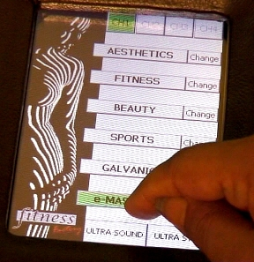
- J-Vac 100 Vacuum Therapy

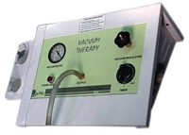

Effects – Vacuum enforces & improve the result when used before electrical stimulation. This results metabolism down the fats.

